Additional file

Fig. S1. Maps showing maximum, median, minimum and standard deviation of habitat suitability obtained with Aedes albopictus Maxent model.

Fig. S2. The relative contribution of five environment variables (BIO11, BIO8, BIO7, BIO2, BIO12) to the model according to the regularized training gain of jackknife test in the Aedes albopictus Maxent model. Blue bars show the influence of each variable alone and green bars show the performance of the model when the variable is removed from the model.

Fig. S3. Response curves showing the relationships between the probability of presence of Aedes albopictus and five environment variables (BIO11, BIO8, BIO7, BIO2, BIO12).
Fig. S4. Presence records and species distribution map obtained with Aedes albopictus Maxent model.
Fig. S5. Relationship between nineteen European bioclimatic variables (www.worldclim.com) for occurrence records buffers of 200 km of radius with histogram and Kernel density (diagonal), Pearson correlation coefficient (r) and its significance (above the diagonal) and scatterplot and linear regression (below the diagonal). *, P ≤ 0.05; **, P ≤ 0.01; ***, P ≤ 0.001.

Fig. S6. Cluster with nineteen European bioclimatic variables (www.worldclim.com) for occurrence records buffers of 200 km of radius.

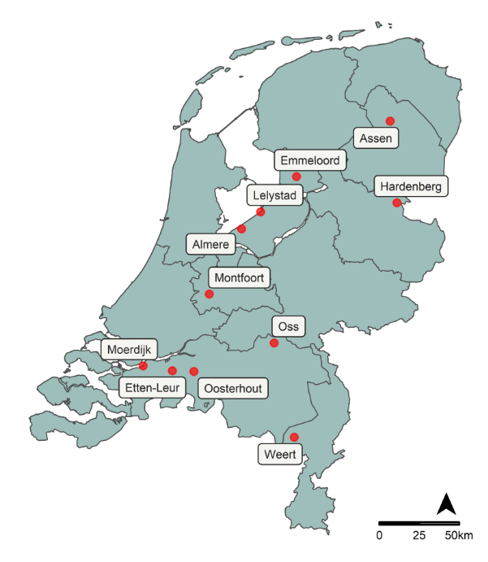
Fig. S7. Map with eleven presence records of Aedes albopictus in Netherlands. The sites are Almere, Assen, Emmeloord, Etten-Leur, Hardenberg, Lelystad, Moerdijk, Montfoort, Oosterhout, Oss, Weert. Map by authors.

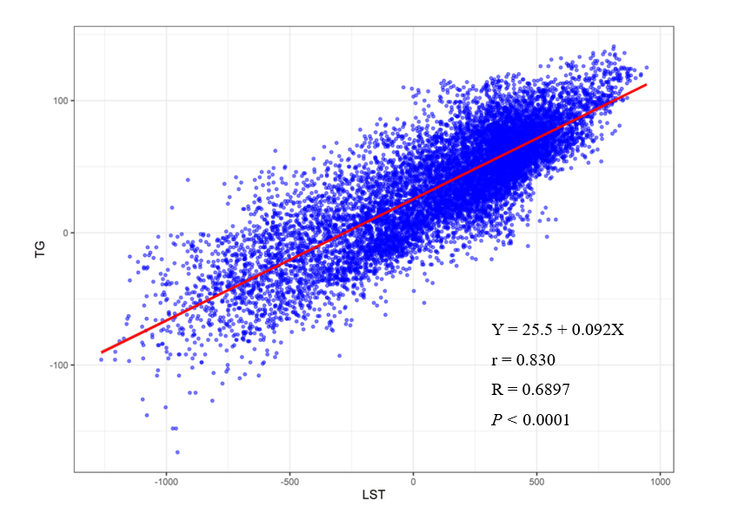
Fig. S8. A scatter plot and the corresponding regression line and regression equation for the relationship between the dependent variable air temperature TG (ºC*0.1) and the independent variable LST (ºC*0.01). r = Pearsons’s correlation coefficient. R = R-squared linear = coefficient of determination. P = P-value.

